Speed-to-Lead Scope: Chatbot, Email and WhatsApp
Oct 14, 2026 · @Muhammad Siraj
Phase 1 ships a website chatbot and an email agent that share one booking core. Phase 2 connects the business's WhatsApp to the same core. Voice calls, ad leads and automated nudges are out of scope for now.

1. Phases and scope
Each phase adds one channel to the same core, so nothing is rebuilt and a failure in one channel does not take down the others.
 | Phase 1: website chatbot | Phase 1: email agent | Phase 2: WhatsApp
Answers questions from the knowledge base | Yes | Yes | Yes
Books a visit | Yes | Yes | Yes
Collects name, phone, email, address, problem | Yes | Yes (email is known) | Yes (phone is known)
Sends the booking confirmation | By email | By email, in the same thread | In WhatsApp, plus email if given
Changes or cancels a booking | No: points the customer to email | Yes, with sender checks | Yes, because WhatsApp confirms the number
Posts new bookings to Slack | Yes | Yes | Yes
Reads job status from Slack and sends a thank-you | Through the email agent | Yes | Yes
Reminder the day before | By email | By email | In WhatsApp, as an approved template
Out of scope for both phases: phone calls and voice, Facebook and Google ad leads, automatic nudges to customers who go quiet, approval gates for late changes, and more than one business. Each can be added later on the same core.

2. How it fits together
Each channel has a thin adapter in front of one shared agent; the agent works only through the tools, and code owns every status change.
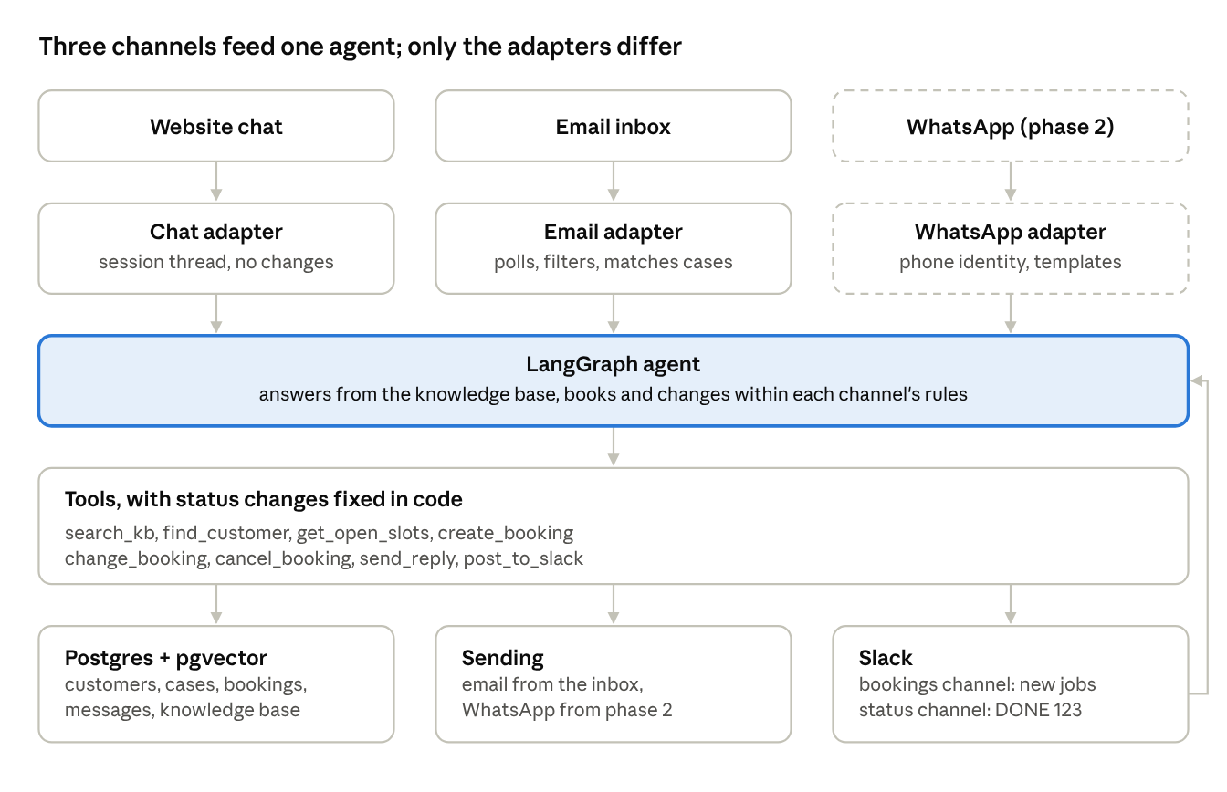
how it fits together · 3 channels, 1 agent, 1 set of tools
The line on the right is the Slack status loop: an employee's DONE 123 comes back into the agent, which sends the thank-you and closes the case. Dashed boxes are phase 2.

One booking, end to end
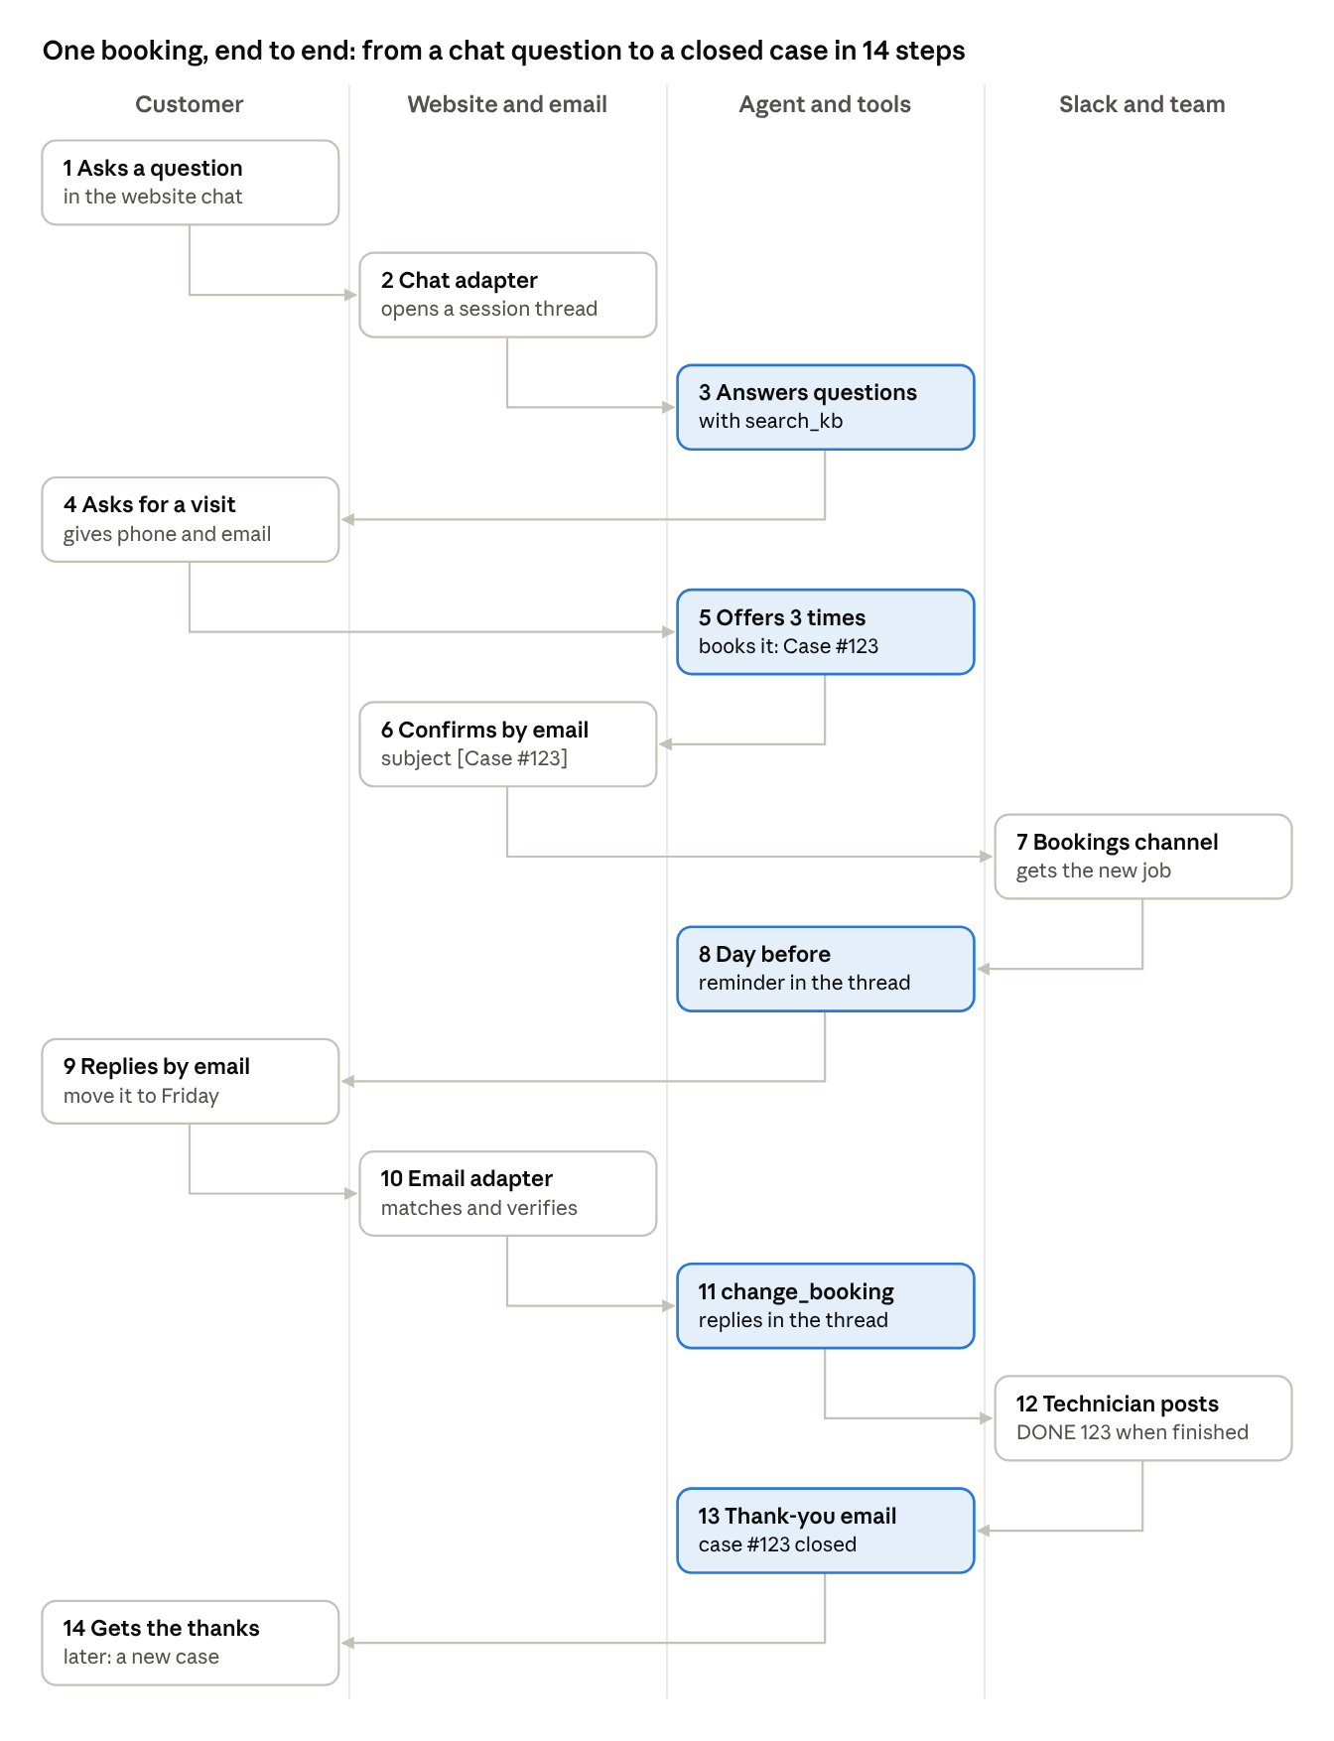
end-to-end flow · one booking, 14 steps, 4 lanes
Steps 1 to 7 happen in one chat visit. The email thread started at step 6 carries everything after it, so the change (steps 9 to 11) and the close (steps 12 to 14) land on the same case. Blue steps are the agent and its tools.
The five LangGraph runs behind this flow, node by node, are in section 12.

3. Shared foundation
All three channels share one agent core, one knowledge base, one set of tools and one database. Each channel only translates messages in and out and decides which tools the agent may use.

Customers and cases
- A customer is one person, with a customer_id that never changes. They are found by email, by phone, or by both.
- A case is one job or enquiry, with its own case_id shown to the customer as "Case #123". It opens with the first message about a job and closes after the thank-you.
- One open case per customer is the normal rule. A message after a case closes opens a new case under the same customer_id, so old and new jobs never mix.
How sure we are of who someone is depends on the channel:
Channel | Identity | How far to trust it
Website chat | Email and phone the visitor types | Not verified; enough to book, not to change a booking
Email | The sender's address, checked with DKIM or DMARC | Verified when the check passes
WhatsApp | The sender's phone number | Verified by WhatsApp

Knowledge base
The agent answers questions only from the business's own documents, using retrieval (RAG).
- Content: services and what each includes, the approved price list, service area, opening hours, cancellation and warranty policies, and common questions. The business owns these documents and updates them.
- Preparation: split each document into short passages, turn each into an embedding, and store them in a kb_chunks table with pgvector.
- Answering: for each question, fetch the 4 closest passages and answer only from them.
- Not found: if no passage is close enough, the agent says it does not know, then offers to book a visit or gives the phone number.
- Updating: rerun the preparation step whenever a document changes.

Agent core and channel rules
One LangGraph agent handles a message from any channel. Each channel adapter turns its input into the same shape (channel, customer, case, text, thread_id) and decides which tools the agent may use:
Tool | Chatbot | Email | WhatsApp
search_kb | Yes | Yes | Yes
find_customer, get_open_slots | Yes | Yes | Yes
create_booking | Yes | Yes | Yes
change_booking, cancel_booking | No | Yes, if the sender is verified | Yes
send_reply (to this conversation only) | Yes | Yes | Yes
post_to_slack | Yes | Yes | Yes
Case status changes never come from the AI directly. They happen inside fixed functions: create_booking sets booked, the Slack status handler sets done, and the thank-you step sets closed.

Tables
Table | Holds
customers | customer_id, name, email, phone, address
cases | case_id, customer_id, status, channel it started on, email_thread_id, timestamps
bookings | booking_id, case_id, slot, service, address, reminded, technician
slots | Open times (or the client's booking software later)
messages | Every message in and out, with channel and the provider's IDs, so nothing is answered twice
kb_chunks | Knowledge-base passages, their embeddings and their source document
slack_events | Status messages already handled, so one DONE 123 is never processed twice

4. Case lifecycle
A case moves forward only through fixed functions and the Slack status channel; the AI can talk, but it cannot jump a case to another status.
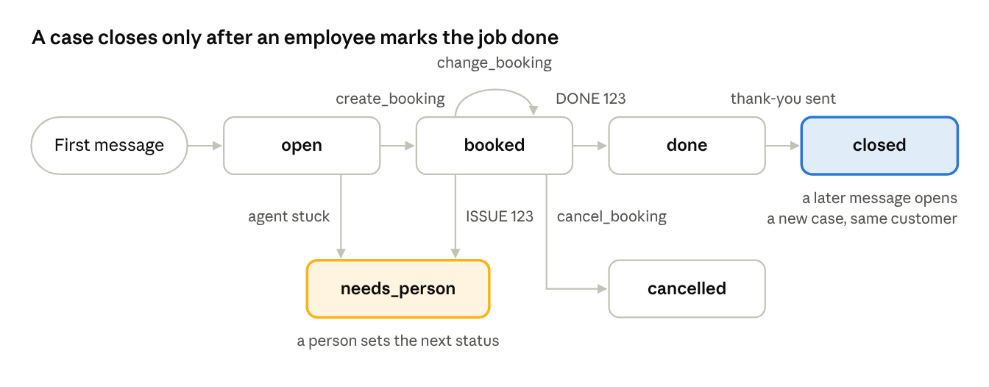
case lifecycle · 6 statuses
Every arrow is a function or a Slack command, never a model decision. needs_person is the safe stop: the AI stops replying on that case until someone in the office decides what comes next.

5. Channel 1: website chatbot
The chatbot answers questions and takes bookings on the website, then hands everything after the booking to email. It never changes or cancels a booking, because it cannot be sure who it is talking to.

How a booking goes
- The visitor asks a question or says what they need. The agent answers from the knowledge base.
- When they want a visit, the agent collects name, phone, email, address, the problem, and a preferred day or time. It asks for one or two items at a time, not a form.
- Code checks the details: the email looks valid, and the phone is a valid number (03001234567 becomes +923001234567).
- The agent offers up to three open times near what they asked for.
- It reads back a summary (service, time, address) and waits for a clear yes.
- create_booking saves the booking and sets the case to booked.
- A confirmation email goes out from the business inbox, with the subject [Case #123] Your AC cleaning visit on Thu 16 Oct, 11:00 AM. It lists the details and says: reply to this email to change or cancel.
- The chat shows the confirmation and the case number.
- The booking is posted to the Slack bookings channel.
Sending the confirmation from the inbox the email agent watches links the two channels. When the customer replies to change something, the reply lands in a thread the email agent already knows (see matching emails to cases, section 6).

Conversation memory
Each chat session gets its own thread ID, so the agent remembers the conversation while the page is open. Once the visitor gives an email or phone that matches an existing customer, the case is linked to that customer. The chat never reveals that customer's other bookings, because the visitor is not verified.

What it refuses
Request | Reply
Change or cancel a booking | "Please reply to your confirmation email for Case #123 and we'll take care of it there."
A price not in the knowledge base | "The technician will confirm the exact price on site."
A diagnosis, or advice on repairing it themselves | Offers a visit instead
Card or payment details | Never asks for or accepts them
Anything unrelated to the business | Brings the conversation back politely

Emergencies
If a message mentions a gas smell, sparks, smoke or flooding, the agent stops the booking flow. It shows the approved safety message and the business's phone number, and posts an urgent alert to Slack.

When something fails
- The AI model is down: the widget shows a short form (name, phone, email, problem). It saves a case with status needs_person and posts it to Slack.
- The confirmation email fails: the chat still shows the case number, and Slack gets an alert to confirm by phone.
- No open times: the agent says the office will email a time, and the case goes to Slack as needs_person.

Acceptance checks
- ☐ A question about hours or area is answered from the knowledge base
- ☐ A question the knowledge base cannot answer gets "I don't know" plus an offer to book
- ☐ A full booking ends with a booking in the database, a confirmation email, a case number in chat and a Slack post
- ☐ An invalid email or phone is caught and asked for again
- ☐ "Can I move my visit?" is pointed to the confirmation email, and nothing changes
- ☐ "Gas smell" shows the safety message and phone number, with no booking flow
- ☐ With the model switched off, the fallback form appears and reaches Slack

6. Channel 2: email agent
The email agent works the business's client-queries inbox through the email MCP: it answers, books, changes bookings for verified senders, and closes each case when an employee marks the job done in Slack. Code decides which emails it sees and who it may reply to.

Waking up
The MCP lets the agent read and send, but it does not announce new mail. A scheduled job runs every 1 to 2 minutes, fetches unread emails, and hands them over oldest first. After an email is handled, it gets a label (ai-handled) and its message ID goes into messages, so it is never answered twice. Push notifications from the email provider can replace polling later.

Filtering, before the AI sees anything
Code skips:
- Automatic replies: headers Auto-Submitted (anything but no), Precedence: bulk, junk or list, and senders like no-reply or mailer-daemon.
- Newsletters: anything with a List-Unsubscribe header.
- The business's own outgoing emails.
- Threads that already got 5 AI replies in the last hour. These go to a person, which stops reply loops with out-of-office messages.

Matching emails to cases
Code tries these in order and stops at the first match:
- Thread ID. The email belongs to a thread already linked to a case.
- Case number in the subject. [Case #123] links it to case 123, even in a brand-new email.
- Sender with one open case. The sender's address belongs to a customer with exactly one open case.
- No match. A new case opens, under the existing customer if the address is known, otherwise under a new customer.
A reply in the thread of a closed case is handled by what it says. A plain "thanks" gets no reply; a new request opens a new case, and the reply carries the new case number.

The conversation
- The agent sees this case's messages in full and a one-line summary of the customer's past cases, never an old case's whole thread.
- It answers from the knowledge base and books with the same steps as the chatbot (section 5). The phone number and address are asked for by email.
- Every reply goes to the original sender, in the same thread, with [Case #123] kept in the subject.

Changing or cancelling a booking
The agent may change or cancel only when all three hold:
- The email is matched to that case (thread ID or case number).
- The sender is the customer on the case.
- The email passes DKIM or DMARC, checked by code from the email's authentication results.
If any check fails, the agent replies that it could not confirm the request and asks them to reply from their registered address, and posts the case to Slack. A change inside 2 hours of the visit always goes to a person.

Slack
Bookings channel. Each new booking, change or cancellation is posted with the case number, customer, service, time, address and phone.
Status channel. Employees post one line per finished job in a fixed format:
Message | Effect
DONE 123 | Case 123 becomes done; a thank-you email goes out in its thread; the case becomes closed
ISSUE 123 <note> | Case 123 becomes needs_person; nothing is sent to the customer
Anything else | The agent replies in Slack with the two formats above
After acting, the agent replies in the Slack thread, for example "Case 123 marked done, thank-you sent", so the team sees it worked. Reading this channel needs a Slack app with permission to read it; a posting-only webhook is not enough.

Reminders
A daily job sends a reminder email the day before each visit, in the case's thread, and marks the booking reminded. The reminder repeats the time and address and says to reply to change or cancel.

Acceptance checks
- ☐ A first email gets a reply within 2 minutes and opens a case
- ☐ Five back-and-forth emails stay on one case, and the booking lands in Slack
- ☐ A new email with [Case #123] in the subject joins case 123
- ☐ An out-of-office reply gets no answer
- ☐ A change request from the customer's verified address moves the booking
- ☐ The same request from a different address changes nothing and reaches Slack
- ☐ DONE 123 in Slack sends the thank-you and closes the case
- ☐ A later email from the same customer opens Case 124 under the same customer
- ☐ Tomorrow's visits get a reminder today, once

7. Channel 3: WhatsApp (phase 2)
WhatsApp reuses the same agent, tools, cases and Slack flow; only a new adapter is built. Because WhatsApp confirms the sender's number, customers may book, change and cancel directly in the chat.

What carries over unchanged
- The knowledge base and every tool in section 3.
- Cases, customers, the Slack bookings and status channels, and DONE 123 closing a case.
- Guardrails and failure handling (section 8).

What is new
- The adapter. Incoming messages arrive on a webhook from the WhatsApp Cloud API; replies go out through its send endpoint. Each message ID is stored so retries are ignored.
- Identity by phone. The sender's number finds the customer. A customer who first booked by email is matched if their phone is on file; otherwise a new customer is created and the office can merge the two later.
- The 24-hour window. Free-form replies are allowed only within 24 hours of the customer's last message. Reminders, thank-yous and anything else sent later must be message templates approved by Meta in advance.
- Templates to prepare: the day-before reminder, the thank-you after DONE, and "the office will contact you".
- Photos and voice notes. Customers often send a photo of the unit or a voice note. In the first version, photos are saved to the case and posted to Slack, and a voice note gets a polite request to type the message.
- Language. Replies follow the customer: English, Urdu or Roman Urdu.
- Opting out. "STOP" ends all messages to that number.

Setting up the number
The business needs a Meta business account and the WhatsApp Business Platform. During development, Meta allows messages only to numbers added as testers. Check early whether the business's current WhatsApp number can stay on the WhatsApp Business app while connected to the API; if not, use a new number for the agent.

Acceptance checks
- ☐ A WhatsApp question is answered from the knowledge base
- ☐ A full booking over WhatsApp lands in the database and in Slack
- ☐ A customer can move a booking in WhatsApp, and Slack shows the change
- ☐ DONE 123 sends the thank-you as a template when the 24-hour window has closed
- ☐ The day-before reminder arrives as a template
- ☐ A photo reaches the Slack bookings channel with its case number
- ☐ STOP ends all further messages

8. Guardrails and failure handling
The agent's tools are limited so tightly that a fooled model can still only send a bad reply. It can never lose, double or wrongly close a booking. Each failure has a fallback that ends with a person informed.

Guardrails
- Customer text is data, never instructions. The prompt says so. More importantly, the tools cannot do anything an email might demand: there is no forward tool, and no way to send to an address the AI chooses.
- Replies go to the sender only. send_reply takes the conversation, not an address; code fills in the recipient and the thread.
- Status changes live in code. booked, done, closed and cancelled are set only inside fixed functions, never by the model.
- Changes need a verified sender. Email changes need a match on the case, the customer's own address and a DKIM or DMARC pass. Chat changes are not allowed. WhatsApp changes rely on the verified number.
- Prices come from the knowledge base only. No discounts or quotes the business has not approved.
- Fixed safety wording. The emergency message is approved text, not generated.
- Loop and flood limits. Automatic emails are skipped, and at most 5 AI replies per thread per hour.
- Code writes confirmations. "You are booked for..." is a template filled after create_booking succeeds, so the model cannot confirm a booking that does not exist.

Failures
Failure | What happens | Who learns of it
AI model down or too slow | Chat shows the fallback form; email and WhatsApp messages wait and are retried on the next run | Slack, after 3 failures in a row
Confirmation email not sent | Retried once; the chat still shows the case number | Slack: "confirm by phone"
Email MCP unreachable | The polling job retries next run; nothing is lost because emails stay unread | Slack, if it fails for 10 minutes
No open times | The customer is told the office will send a time | Slack, case marked needs_person
Chosen time taken meanwhile | New times are offered | Nobody needs to
Sender not verified for a change | Nothing changes; the customer is asked to reply from their registered address | Slack
DONE for an unknown or unbooked case | Nothing changes; the agent replies in Slack with the problem | The employee who posted
Same email, WhatsApp message or Slack post processed twice | Ignored by its stored ID | Nobody needs to
A message the agent cannot handle | The case becomes needs_person and the AI stops replying on it | Slack

9. Tech stack
Python throughout, one Postgres database for everything, and LangGraph for the agent.
Part | Choice | Notes
Agent | LangGraph, with a Postgres checkpointer | One thread per chat session, email case or WhatsApp number
Backend | FastAPI | Chat endpoint, WhatsApp webhook, Slack events, health check
Database | Postgres with pgvector | Neon's free plan is enough for the demo
Knowledge base | pgvector table kb_chunks plus an embedding model | Rebuilt by a script when documents change
AI model | A small, fast model with tool calling | Groq or Google AI Studio free tiers for the demo
Chat widget | A small script on the website, calling the chat endpoint | You already build these sites
Email | The email MCP on the client-queries inbox | A scheduled job polls every 1 to 2 minutes
Slack | A Slack app: post to the bookings channel, read the status channel | A webhook alone can only post
Scheduler | APScheduler inside the app | Email polling and daily reminders
WhatsApp (phase 2) | WhatsApp Cloud API | Webhook in, send endpoint out, templates outside 24 hours
The agent server must be able to reach the email MCP. If the MCP runs only on someone's laptop, move it to the same server as the agent before going live.

10. Build order
Build one working slice at a time; don't start the next step until the check passes.
- Database and demo data. Create the tables in section 3 and seed a made-up business with open times.
  - Check: the seed shows customers and a week of slots.
- Knowledge base. Write the business documents, build kb_chunks, and add search_kb.
  - Check: ten sample questions retrieve the right passages.
- Booking tools. find_customer, get_open_slots, create_booking, change_booking, cancel_booking, with tests.
  - Check: the same booking twice gives one booking; a taken time raises an error.
- Chatbot agent, in the terminal. The LangGraph agent with chatbot rules, before any website.
  - Check: a typed conversation answers questions and books a visit.
- Chat widget and confirmation email. Put the widget on a demo page; send confirmations from the inbox.
  - Check: a booking on the page produces the email with [Case #N] in the subject.
- Slack bookings channel.
  - Check: every booking appears in Slack with its case number.
- Email agent: reading and replying. The polling job, filters and case matching, answering only.
  - Check: replies arrive within 2 minutes; an out-of-office message gets none.
- Email agent: booking and changes. Add booking, then changes with the sender checks.
  - Check: the section 6 acceptance checks for booking and changes pass.
- Slack status loop and reminders. Read DONE and ISSUE, send thank-yous, close cases, send reminders.
  - Check: DONE 123 closes the case and the customer gets the thank-you.
- Demo run. Reset the data, then run the whole story: chat booking, email change, DONE, thank-you.
  - Check: it runs twice in a row without touching code.
- WhatsApp (phase 2). Adapter, templates, then the section 7 checks.
  - Check: a real phone books, changes and gets the thank-you.

11. Open questions
- ☐ Is the client-queries inbox on Gmail or Outlook? It decides how the agent verifies senders and whether push notifications can replace polling.
- ☐ Where does the email MCP run, and can the agent server reach it?
- ☐ What happens after an employee posts in the Slack status channel, beyond DONE and ISSUE? (The earlier message describing this was cut off.)
- ☐ Who in the office handles needs_person cases and urgent alerts, and in which Slack channel?
- ☐ What is the late-change limit: is 2 hours before a visit right?
- ☐ Which documents form the knowledge base, and who keeps the price list current?
- ☐ What time should the daily reminder go out?
- ☐ For WhatsApp: can the business's current number stay on the WhatsApp Business app while connected to the API, or does the agent need a new number?

12. Agent runs
Five LangGraph runs carry the three channels. Each starts on its own trigger and finishes on its own; they never call each other and share work only through the database.
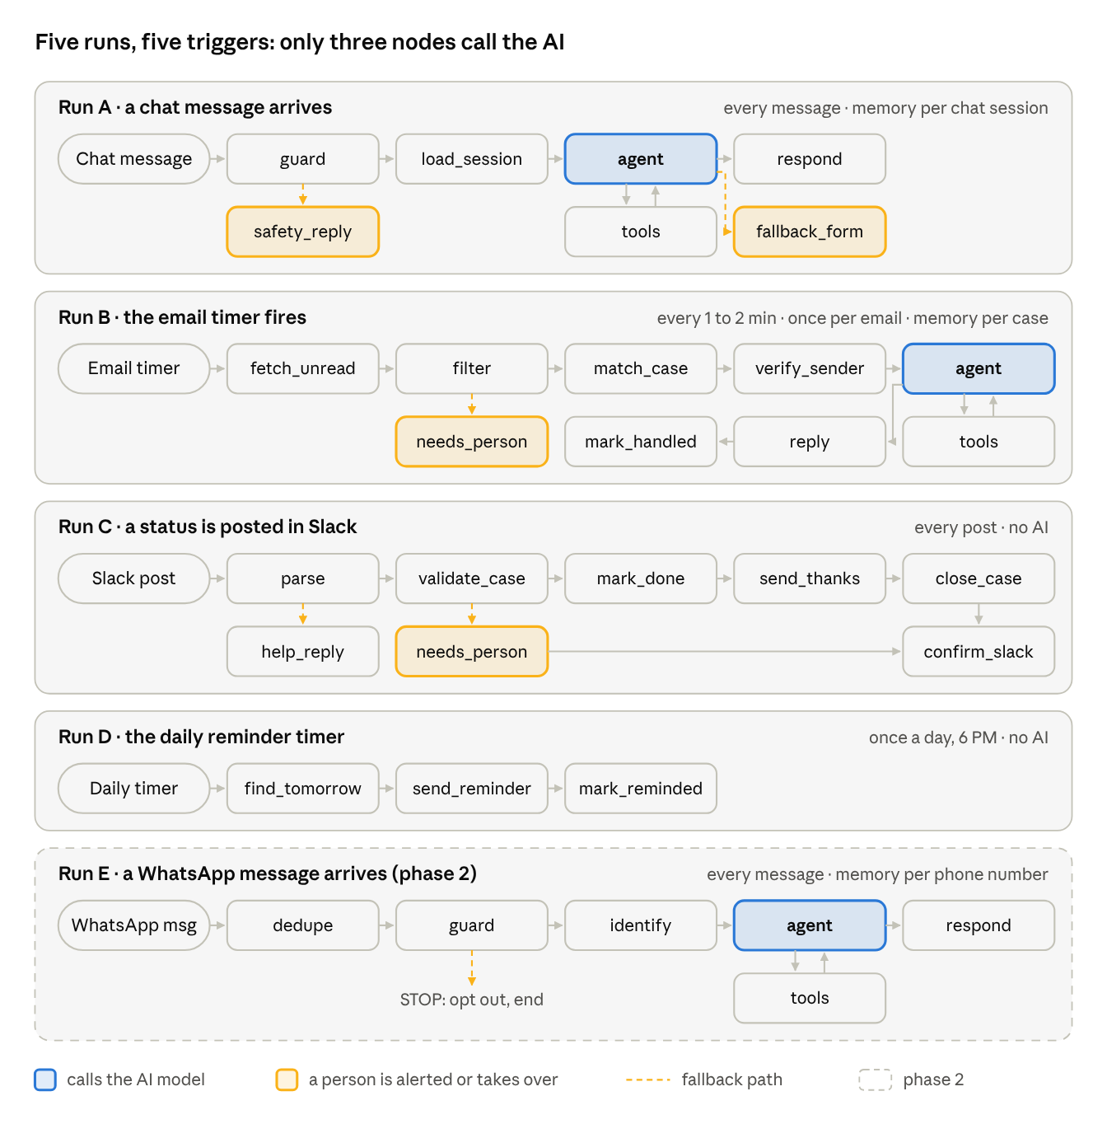
agent runs · 5 triggers, 3 AI nodes
Read each lane left to right; the second row holds the tools each agent calls and the fallbacks. Only the three blue nodes call the AI model; everything else is plain code.

Triggers
Run | Started by | How often | Memory (thread) | AI
A | A visitor sends a chat message | Every message | One per chat session | Yes
B | A timer checks the inbox through the email MCP | Every 1 to 2 minutes | One per case | Yes
C | An employee posts in the Slack status channel | Every post, as a Slack event | None | No
D | A daily timer | Once a day, 6 PM | None | No
E | A WhatsApp message reaches the webhook (phase 2) | Every message | One per phone number | Yes
The email timer sets how long a customer waits: at 15 minutes, each reply can take up to 15 minutes. A check that finds no new mail uses no AI, so 1 to 2 minutes costs almost nothing.

Run A: a chat message arrives
Node | Kind | What it does | If it fails
guard | Code | Checks for emergency words; on a match goes to safety_reply
safety_reply | Person alerted | Shows the safety message and phone number; urgent Slack alert
load_session | Code | Restores the chat; links the customer once email or phone matches, without showing their other bookings
agent | AI | Answers, asks for a detail, offers times, or calls a tool | Model down: fallback_form
tools | Code | search_kb, get_open_slots, create_booking; booking also sends the confirmation email and Slack post | Time taken meanwhile: new times offered
respond | Code | Sends the reply to the chat window
fallback_form | Person alerted | Short form; saves a needs_person case; Slack alert

Run B: the email timer fires
fetch_unread runs once per tick; the rest runs once per email, oldest first.
Node | Kind | What it does | If it fails
fetch_unread | Code | Reads unread emails through the email MCP | MCP unreachable: retried next tick; Slack alert after 10 minutes
filter | Code | Skips auto-replies, newsletters and own mail; over 5 AI replies an hour on a thread goes to a person | Over the limit: needs_person
match_case | Code | Thread ID, then [Case #N] in the subject, then a sender with one open case; otherwise a new case
verify_sender | Code | DKIM or DMARC pass, and the sender is the case's customer; sets verified | Not verified: change tools withheld
agent | AI | Reads this case in full plus a one-line summary of past cases; decides the next step | Model down: email stays unread for the next tick
tools | Code | As Run A, plus change_booking and cancel_booking when verified; a change inside 2 hours goes to a person
reply | Code | To the sender only, in the same thread, keeping [Case #N]
mark_handled | Code | Labels the email ai-handled and stores its message ID
needs_person | Person alerted | AI stops on this case; Slack alert

Run C: a status is posted in Slack
Node | Kind | What it does | If it fails
parse | Code | Reads DONE 123 or ISSUE 123 <note> | Other text: help_reply
validate_case | Code | Case exists, is booked, and this post was not handled before | Not valid: reason posted in Slack
mark_done | Code | Sets the case to done
send_thanks | Code | Thank-you in the case's email thread, or a WhatsApp template | Send fails: Slack alert to thank by phone
close_case | Code | Sets the case to closed; a later message opens a new case
confirm_slack | Code | Replies in the Slack thread: "Case 123 marked done, thank-you sent"
needs_person | Person alerted | For ISSUE: case set to needs_person; nothing sent to the customer
help_reply | Code | Replies with the two accepted formats

Run D: the daily reminder timer
Node | Kind | What it does | If it fails
find_tomorrow | Code | Booked visits tomorrow, not yet reminded, in the business's time zone
send_reminder | Code | Time, address and "reply to change or cancel", by email thread or WhatsApp template | Send fails: Slack alert to remind by phone
mark_reminded | Code | Marks the booking so it is never reminded twice

Run E: a WhatsApp message arrives (phase 2)
Node | Kind | What it does | If it fails
dedupe | Code | Stops if this message ID was handled before
guard | Code | STOP opts out and ends; emergency words get the safety reply and an urgent Slack alert
identify | Code | Finds the customer by phone and their open case, or opens one
agent | AI | As Run A, with change and cancel allowed | Model down: "we'll reply shortly" and a Slack alert
tools | Code | The full set: knowledge, booking and changes
respond | Code | Free text within 24 hours of the customer's last message; approved template outside it

speed-to-lead/
├── app/ # the main backend (one Python package)
│ ├── main.py # FastAPI app: mounts routers, starts scheduler
│ ├── config.py # settings from .env (pydantic-settings)
│ │
│ ├── api/ # HTTP entry points only, no business logic
│ │ ├── chat.py # POST /chat → Run A (website widget)
│ │ ├── slack_events.py # Slack Events API → Run C
│ │ ├── whatsapp_webhook.py # Meta webhook verify + inbound → Run E
│ │ ├── admin.py # onboard client, upload KB, re-index
│ │ └── health.py
│ │
│ ├── graphs/ # one folder per LangGraph run
│ │ ├── common/
│ │ │ ├── state.py # shared TypedDicts (Customer, Case, Message)
│ │ │ ├── checkpointer.py # PostgresSaver setup
│ │ │ └── llm.py # model client + prompts loader
│ │ ├── run_a_chat/ # graph.py, nodes.py, prompts/
│ │ ├── run_b_email/ # inbox poll → match case → reply/book
│ │ ├── run_c_slack_status/ # DONE/ISSUE → close case, thank-you
│ │ ├── run_d_reminders/ # daily 6 PM, day-before reminders
│ │ └── run_e_whatsapp/ # phase 2
│ │
│ ├── tools/ # what the graphs call; plain functions
│ │ ├── booking.py # get_slots, book, cancel (real calendar or Housecall Pro later)
│ │ ├── cases.py # open/close case, status changes (code only, never the LLM)
│ │ ├── notify.py # send email, Slack post, WhatsApp template
│ │ └── guardrails.py # DKIM/DMARC check, auto-reply filter, reply rate limit
│ │
│ ├── rag/
│ │ ├── ingest.py # load .md files → chunk by "##" → embed → pgvector
│ │ ├── retriever.py # search(client_id, query, k)
│ │ └── chunking.py
│ │
│ ├── mcp/ # MCP *clients*: how the app talks to MCP servers
│ │ ├── client.py # connect, list tools, call tool, timeouts/retries
│ │ └── email_mcp.py # wrappers: list_new(), get_thread(), reply()
│ │
│ ├── channels/ # convert each channel to/from one Message shape
│ │ ├── web.py
│ │ ├── email.py
│ │ └── whatsapp.py
│ │
│ ├── scheduler/
│ │ └── jobs.py # APScheduler: Run B every 1–2 min, Run D daily
│ │
│ ├── db/
│ │ ├── models.py # clients, customers, cases, messages, bookings (client_id on all)
│ │ ├── session.py
│ │ └── migrations/ # Alembic
│ │
│ └── tenants/
│ └── resolver.py # widget key / inbox / Slack team → client_id + their settings
│
├── mcp_servers/ # MCP *servers* you run yourself (own processes)
│ └── email_server/ # Gmail/Outlook MCP; only reply-to-sender, no forward tool
│
├── widget/ # the embeddable chat script
│ ├── src/widget.js # <script data-client="company-x">
│ └── build/
│
├── knowledge/ # per-client KB source files
│ └── mdcold/ # the 18 .md files from today
│
├── tests/
│ ├── graphs/ # one test file per run, fake tools
│ ├── rag/ # the 30 test questions as an eval
│ └── fixtures/ # sample emails, Slack events, WhatsApp payloads
│
├── scripts/ # seed_demo_client.py, reindex_kb.py
├── docker-compose.yml # api + postgres(pgvector) + email MCP
├── Dockerfile
├── .env.example
└── pyproject.toml

